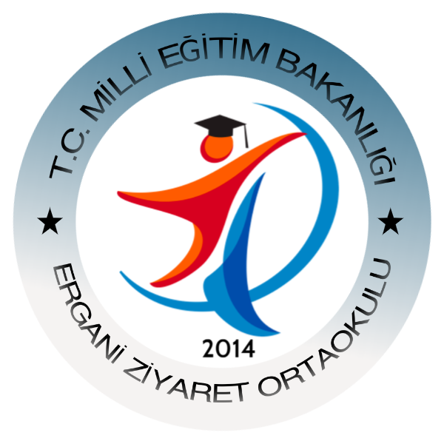
eTwinning Features Policy
Our institution has needs in terms of quality improvement, both institutionally and in terms of management and education personnel.
From the point of view of personnel; it is necessary for the teachers to develop their competence to make more conscious activities with appropriate, effective, modern methods and techniques for the purpose of development of professional, language, communication skills and especially guidance and guidance towards the students and to acquire the digital skills required by the age.
E-twinnig
The e-Twinning platform will play a crucial role in communicating, cooperating, developing our proj- eme, sharing project experiences and interacting with our teachers, who are directly beneficiary of our project, with our students in the final beneficiary status.
The active use of this field will contribute to our administrators and teachers communicating with their colleagues at European level, promoting their projects, sharing their good practices, mutual transfer of good practices and even creating new collaborations in the future. Our students will also have the opportunity to meet their peers and communicate with people from different cultures. The use of the E-Twinning Platform will contribute to the formation of intercultural dialogue by enabling the development of language and digital skills of our students as well as our students.
Our school continues to keep pace with the speed of technology, activities and projects designed for development. Our school carried out activities to inform and educate the school employees, parents and course students due to the Secure Internet Day (SID) in February, following the coding training and certificate ceremony that they gave to approximately 200 students within the scope of the coding week. Within the scope of the ongoing eTwinning projects with a group of students, applications such as animals 4d, quiver, tagul, classdojo have been learned. As the students become conscious users, web tools have begun to be integrated into the lectures. These activities create opportunities for students to make the student enjoyable and lasting.

